Practical 2: Design static web pages for your college containing a description of the courses, departments, faculties, library etc. Provide links for navigation among pages

Home Page

<html lang="en">

<head>

<title>VGEC</title>

<meta charset="utf-8">

<meta name="viewport" content="width=device-width, initial-scale=1">

<link rel="stylesheet" href="https://maxcdn.bootstrapcdn.com/bootstrap/4.4.1/css/bootstrap.min.css">

<script src="https://ajax.googleapis.com/ajax/libs/jquery/3.4.1/jquery.min.js"></script>

<script src="https://cdnjs.cloudflare.com/ajax/libs/popper.js/1.16.0/umd/popper.min.js"></script>

<script src="https://maxcdn.bootstrapcdn.com/bootstrap/4.4.1/js/bootstrap.min.js"></script>

<style type="text/css">

body{

background-color: gray;

}

</style>

</head>

<body>

<div class="container" style="background-color: white">

<div class="row">

<div class="col-sm-2">

<img src="college.png" width="150" height="150">

</div>

<div class="col-sm-10" align="center" style="padding-top: 25px;">

<h2>Vishwakarma Government Engineering College Chandkheda, Ahmedabad</h2>

</div>

</div>

<nav class="navbar navbar-expand-sm bg-dark navbar-dark">

<ul class="navbar-nav">

<li class="nav-item active">

<a class="nav-link " href="home.html">Home</a>

</li>

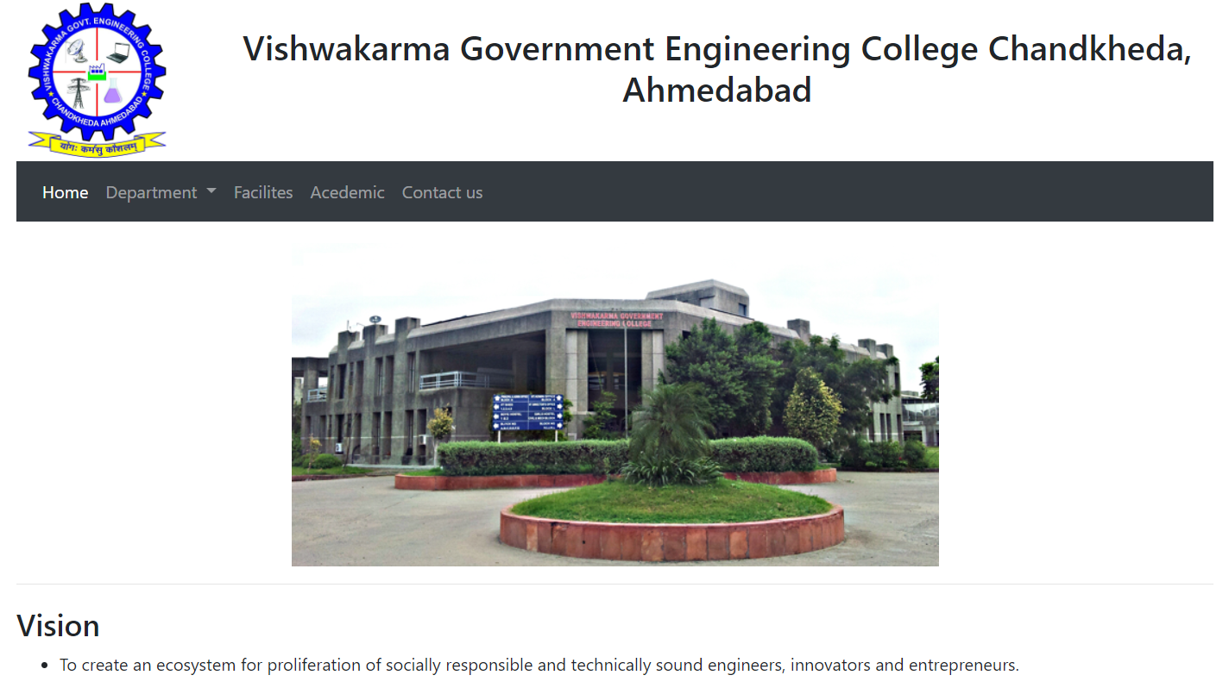

<li class="nav-item dropdown">

<a class="nav-link dropdown-toggle" href="#" id="navbardrop" data-toggle="dropdown">

Department

</a>

<div class="dropdown-menu">

<a class="dropdown-item" href="it.html">Information Technology</a>

<a class="dropdown-item" href="ce.html">Computer Engineering</a>

<a class="dropdown-item" href="ec.html">Electronics & Communication</a>

<a class="dropdown-item" href="e.html">Electrical Engineering</a>

</div>

</li>

<li class="nav-item">

<a class="nav-link" href="#">Facilites</a>

</li>

<li class="nav-item">

<a class="nav-link" href="#">Acedemic</a>

</li>

<li class="nav-item">

<a class="nav-link" href="#">Contact us</a>

</li>

</ul>

</nav>

<div style="margin-top: 20px;" align="center">

<img src="vgec_college.png">

</div>

<hr>

<div style="margin-top: 20px;">

<h3>Vision</h3>

<ul>

<li><p>To create an ecosystem for proliferation of socially responsible and technically sound engineers, innovators and entrepreneurs.</p></li>

</ul>

</div>

<hr>

<div style="margin-top: 20px; padding-bottom: 20px;">

<h3>Mission</h3>

<ul>

<li><p>To develop state-of-the-art laboratories and well-equipped academic infrastructure.</p></li>

<li><p>To motivate faculty and staff for qualification up-gradation, and enhancement of subject knowledge.</p></li>

<li><p>To promote research, innovation and real life problem solving skills.</p></li>

<li><p>To strengthen linkages with industries, academic and research organizations.</p></li>

<li><p>To reinforce concern for sustainability, natural resource conservation and social responsibility</p></li>

</ul>

</div>

</div>

Information Technology Department Page

<html lang="en">

<head>

<title>VGEC</title>

<meta charset="utf-8">

<meta name="viewport" content="width=device-width, initial-scale=1">

<link rel="stylesheet" href="https://maxcdn.bootstrapcdn.com/bootstrap/4.4.1/css/bootstrap.min.css">

<script src="https://ajax.googleapis.com/ajax/libs/jquery/3.4.1/jquery.min.js"></script>

<script src="https://cdnjs.cloudflare.com/ajax/libs/popper.js/1.16.0/umd/popper.min.js"></script>

<script src="https://maxcdn.bootstrapcdn.com/bootstrap/4.4.1/js/bootstrap.min.js"></script>

<style type="text/css">

body{

background-color: gray;

}

</style>

</head>

<body>

<div class="container" style="background-color: white">

<div class="row">

<div class="col-sm-2">

<img src="college.png" width="150" height="150">

</div>

<div class="col-sm-10" align="center" style="padding-top: 25px;">

<h2>Vishwakarma Government Engineering College Chandkheda, Ahmedabad</h2>

</div>

</div>

<nav class="navbar navbar-expand-sm bg-dark navbar-dark">

<ul class="navbar-nav">

<li class="nav-item ">

<a class="nav-link " href="home.html">Home</a>

</li>

<li class="nav-item active dropdown">

<a class="nav-link dropdown-toggle" href="#" id="navbardrop" data-toggle="dropdown">

Department </a>



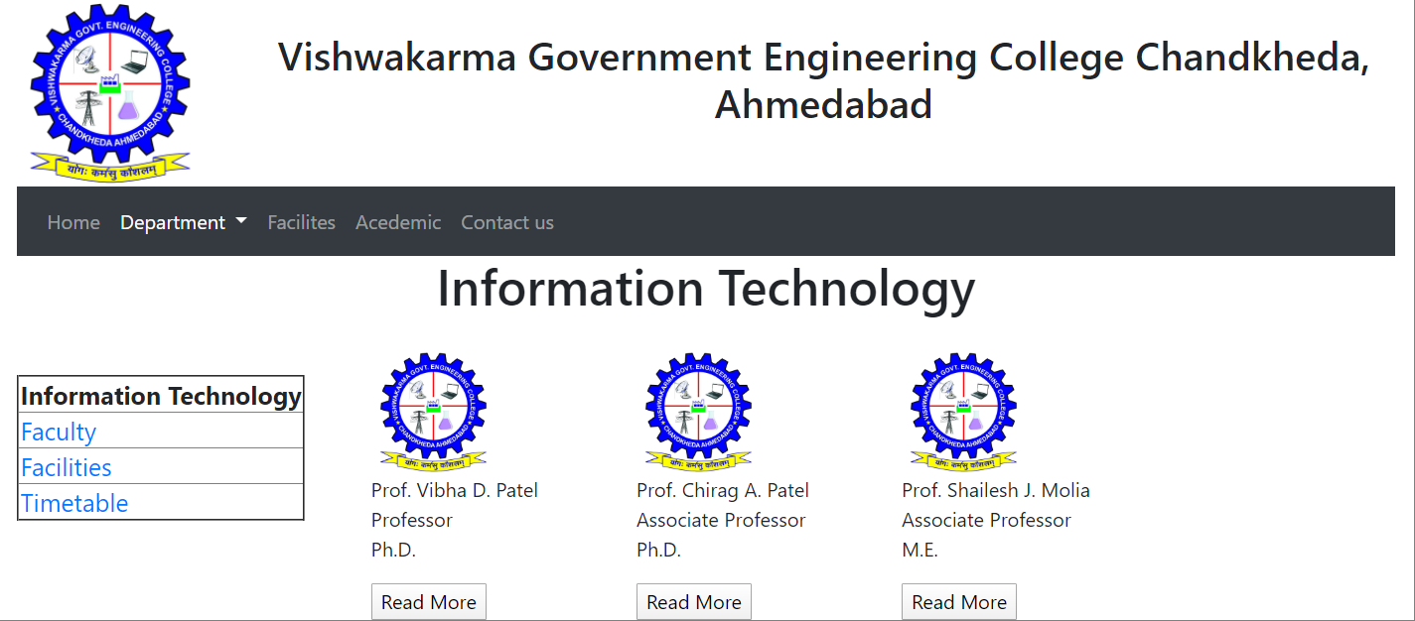

<div class="dropdown-menu">

<a class="dropdown-item" href="it.html">Information Technology</a>

<a class="dropdown-item" href="ce.html">Computer Engineering</a>

<a class="dropdown-item" href="ec.html">Electronics & Communication</a>

<a class="dropdown-item" href="e.html">Electrical Engineering</a>

</div>

</li>

<li class="nav-item">

<a class="nav-link" href="#">Facilites</a>

</li>

<li class="nav-item">

<a class="nav-link" href="#">Acedemic</a>

</li>

<li class="nav-item">

<a class="nav-link" href="#">Contact us</a>

</li>

</ul>

</nav>

<div align="center">

<h1>Information Technology</h1>

</div>

<div class="row">

<div class="col-sm-3" style="margin-top: 20px; padding-bottom: 20px;" >

<table border="2" style="font-size: 20px;">

<tr>

<td><b>Information Technology</b></td>

</tr>

<tr>

<td><a href="faculty.html">Faculty</a></td>

</tr>

<tr>

<td><a href="facilities.html">Facilities</a></td>

</tr>

<tr>

<td><a href="timetable.html">Timetable</a></td>

</tr>

</table>

</div>

<div class="col-sm-9">

<div style="margin-top: 20px;">

<h3>Vision</h3>

<ul>

<li><p>The department aims to nurture students to be IT professionals who are innovative and technically competent to meet the advancements in industrial and societal needs.</p></li>

</ul>

</div>

<hr>

<div style="margin-top: 20px; padding-bottom: 20px;">

<h3>Mission</h3>

<ul>

<li><p>To produce technically competent and socially responsible graduates.</p></li>

<li><p>To develop well-equipped laboratories to gain practical exposure in IT practices.</p></li>

<li><p>To support research culture, consultancy work and enhancement of entrepreneurship skills.</p></li>

<li><p>To enhance industry linkage for good placements and real-world exposure.</p></li>

<li><p>To encourage, involve and support students for environmental and social wellbeing.</p></li>

</ul>

</div>

</div>

</div></div>

Facilities Page

<html lang="en">

<head>

<title>VGEC</title>

<meta charset="utf-8">

<meta name="viewport" content="width=device-width, initial-scale=1">

<link rel="stylesheet" href="https://maxcdn.bootstrapcdn.com/bootstrap/4.4.1/css/bootstrap.min.css">

<script src="https://ajax.googleapis.com/ajax/libs/jquery/3.4.1/jquery.min.js"></script>

<script src="https://cdnjs.cloudflare.com/ajax/libs/popper.js/1.16.0/umd/popper.min.js"></script>

<script src="https://maxcdn.bootstrapcdn.com/bootstrap/4.4.1/js/bootstrap.min.js"></script>

<style type="text/css">

body{

background-color: gray;

}

</style>

</head>

<body>

<div class="container" style="background-color: white">

<div class="row">

<div class="col-sm-2">

<img src="college.png" width="150" height="150">

</div>

<div class="col-sm-10" align="center" style="padding-top: 25px;">

<h2>Vishwakarma Government Engineering College Chandkheda, Ahmedabad</h2>

</div>

</div>

<nav class="navbar navbar-expand-sm bg-dark navbar-dark">

<ul class="navbar-nav">

<li class="nav-item ">

<a class="nav-link " href="home.html">Home</a>

</li>

<li class="nav-item active dropdown"><a class="nav-link dropdown-toggle" href="#" id="navbardrop" data-toggle="dropdown">

Department

</a>

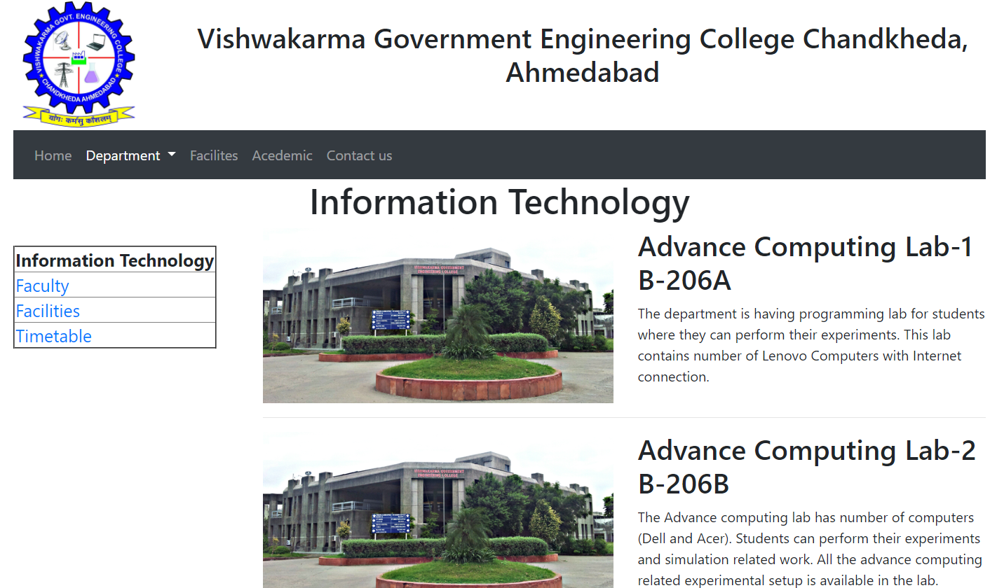

<div class="dropdown-menu">

<a class="dropdown-item" href="it.html">Information Technology</a>

<a class="dropdown-item" href="ce.html">Computer Engineering</a>

<a class="dropdown-item" href="ec.html">Electronics & Communication</a>

<a class="dropdown-item" href="e.html">Electrical Engineering</a>

</div>

</li>

<li class="nav-item">

<a class="nav-link" href="#">Facilites</a>

</li>

<li class="nav-item">

<a class="nav-link" href="#">Acedemic</a>

</li>

<li class="nav-item">

<a class="nav-link" href="#">Contact us</a>

</li>

</ul>

</nav>

<div align="center">

<h1>Information Technology</h1>

</div>

<div class="row">

<div class="col-sm-3" style="margin-top: 20px; padding-bottom: 20px;" >

<table border="2" style="font-size: 20px;">

<tr>

<td><b>Information Technology</b></td>

</tr>

<tr>

<td><a href="faculty.html">Faculty</a></td>

</tr>

<tr>

<td><a href="facilities.html">Facilities</a></td>

</tr>

<tr>

<td><a href="timetable.html">Timetable</a></td>

</tr>

</table>

</div>

<div class="col-sm-9">

<div class="row">

<div class="col-sm-6">

<img src="vgec_college.png" width="400" height="200">

</div>

<div class="col-sm-6">

<h2>Advance Computing Lab-1 B-206A</h2>

<p>The department is having programming lab for students where they can perform their experiments. This lab contains number of Lenovo Computers with Internet connection.</p>

</div>

</div>

<hr>

<div class="row">

<div class="col-sm-6">

<img src="vgec_college.png" width="400" height="200">

</div>

<div class="col-sm-6">

<h2>Advance Computing Lab-2 B-206B</h2>

<p>The Advance computing lab has number of computers (Dell and Acer). Students can perform their experiments and simulation related work. All the advance computing related experimental setup is available in the lab.</p>

</div>

</div> </div> </div>

</div></body></html>

</html>

Practical 3: Create your class timetable using table tag.

<html lang="en">

<head>

<title>VGEC</title>

<meta charset="utf-8">

<meta name="viewport" content="width=device-width, initial-scale=1">

<link rel="stylesheet" href="https://maxcdn.bootstrapcdn.com/bootstrap/4.4.1/css/bootstrap.min.css">

<script src="https://ajax.googleapis.com/ajax/libs/jquery/3.4.1/jquery.min.js"></script>

<script src="https://cdnjs.cloudflare.com/ajax/libs/popper.js/1.16.0/umd/popper.min.js"></script>

<script src="https://maxcdn.bootstrapcdn.com/bootstrap/4.4.1/js/bootstrap.min.js"></script>

<style type="text/css">

body{

background-color: gray;

}

</style>

</head>

<body>

<div class="container" style="background-color: white">

<div class="row">

<div class="col-sm-2">

<img src="college.png" width="150" height="150">

</div>

<div class="col-sm-10" align="center" style="padding-top: 25px;">

<h2>Vishwakarma Government Engineering College Chandkheda, Ahmedabad</h2>

</div>

</div>

<nav class="navbar navbar-expand-sm bg-dark navbar-dark">

<ul class="navbar-nav">

<li class="nav-item ">

<a class="nav-link " href="home.html">Home</a>

</li>

<li class="nav-item active dropdown">

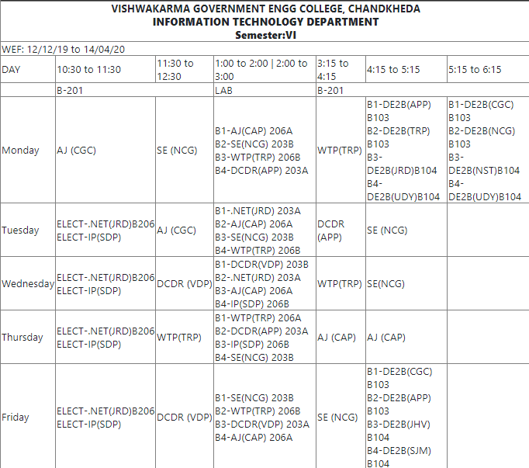

<a class="nav-link dropdown-toggle" href="#" id="navbardrop" data-toggle="dropdown">

Department

</a>

<div class="dropdown-menu">

<a class="dropdown-item" href="it.html">Information Technology</a>

<a class="dropdown-item" href="ce.html">Computer Engineering</a>

<a class="dropdown-item" href="ec.html">Electronics & Communication</a>

<a class="dropdown-item" href="e.html">Electrical Engineering</a>

</div>

</li>

<li class="nav-item">

<a class="nav-link" href="#">Facilites</a>

</li>

<li class="nav-item">

<a class="nav-link" href="#">Acedemic</a>

</li>

<li class="nav-item">

<a class="nav-link" href="#">Contact us</a>

</li>

</ul>

</nav>

<div class="row" >

<div class="col-sm-3" style="margin-top: 20px; padding-bottom: 20px;" >

<table border="2" style="font-size: 20px;">

<tr>

<td><b>Information Technology</b></td>

</tr>

<tr>

<td><a href="faculty.html">Faculty</a></td>

</tr>

<tr>

<td><a href="facilities.html">Facilities</a></td>

</tr>

<tr>

<td><a href="timetable.html">Timetable</a></td>

</tr>

</table>

</div>

<div class="col-sm-9" style="padding-top: 20px; padding-bottom: 20px;">

<table border="3px" style="border-collapse: collapse;" align="center" cellpadding="1">

<tr align="center">

<td colspan="7" rowspan="1"><b>VISHWAKARMA GOVERNMENT ENGG COLLEGE, CHANDKHEDA<b></br>

<b>INFORMATION TECHNOLOGY DEPARTMENT<b></br><b>Semester:VI<b></b>

</td>

</tr>

<tr>

<td colspan="7" style="margin-right: 10px;">WEF: 12/12/19 to 14/04/20</td>

</tr>

<tr>

<td>DAY</td>

<td>10:30 to 11:30</td>

<td>11:30 to 12:30</td>

<td>1:00 to 2:00 | 2:00 to 3:00</td>

<td>3:15 to 4:15 </td>

<td>4:15 to 5:15</td>

<td>5:15 to 6:15</td>

</tr>

<tr>

<td></td>

<td colspan="2">B-201</td>

<td>LAB</td>

<td colspan="3">B-201</td>

</tr>

<tr>

<td>Monday</td>

<td>AJ (CGC)</td>

<td>SE (NCG) </td>

<td>B1-AJ(CAP) 206A</br>

B2-SE(NCG) 203B</br>

B3-WTP(TRP) 206B</br>

B4-DCDR(APP) 203A</td>

<td>WTP(TRP)</td>

<td>B1-DE2B(APP) B103</br>

B2-DE2B(TRP) B103</br>

B3-DE2B(JRD)B104</br>

B4-DE2B(UDY)B104</td>

<td>B1-DE2B(CGC) B103</br>

B2-DE2B(NCG) B103</br>

B3-DE2B(NST)B104</br>

B4-DE2B(UDY)B104</td>

</tr>

<tr>

<td>Tuesday</td>

<td>ELECT-.NET(JRD)B206</br>

ELECT-IP(SDP)</td>

<td>AJ (CGC)</td>

<td>B1-.NET(JRD) 203A</br>

B2-AJ(CAP) 206A</br>

B3-SE(NCG) 203B</br>

B4-WTP(TRP) 206B</td>

<td>DCDR (APP)</td>

<td>SE (NCG)</td>

<td></td>

</tr>

<tr>

<td>Wednesday</td>

<td>ELECT-.NET(JRD)B206</br>

ELECT-IP(SDP)</td>

<td>DCDR (VDP)</td>

<td>B1-DCDR(VDP) 203B</br>

B2-.NET(JRD) 203A</br>

B3-AJ(CAP) 206A</br>

B4-IP(SDP) 206B</td>

<td>WTP(TRP)</td>

<td>SE(NCG)</td>

<td></td>

</tr>

<tr>

<td>Thursday</td>

<td>ELECT-.NET(JRD)B206</br>

ELECT-IP(SDP)</td>

<td>WTP(TRP)</td>

<td>B1-WTP(TRP) 206A</br>

B2-DCDR(APP) 203A</br>

B3-IP(SDP) 206B</br>

B4-SE(NCG) 203B</td>

<td>AJ (CAP)</td>

<td>AJ (CAP)</td>

<td></td>

</tr>

<tr>

<td>Friday</td>

<td>ELECT-.NET(JRD)B206</br>

ELECT-IP(SDP)</td>

<td>DCDR (VDP)</td>

<td>B1-SE(NCG) 203B</br>

B2-WTP(TRP) 206B</br>

B3-DCDR(VDP) 203A</br>

B4-AJ(CAP) 206A</td>

<td>SE (NCG)</td>

<td>B1-DE2B(CGC) B103</br>

B2-DE2B(APP) B103</br>

B3-DE2B(JHV) B104</br>

B4-DE2B(SJM) B104</td>

<td></td> </tr> </table> </div> </div></div></body></html>